Deploying an Azure VM using PowerShell:

1. Login Azure portal
2. Create Storage Account
3. Top right corner -> Cloud Shell
4. Advanced Settings
5. Type storage account ID
6. Cloud-shell
7. Create
8. Connect to terminal
9. $resourceGroup = “PowerShellRGlod23134448”
10. $location = “eastus”
11. $vmName = “Challenge-VM”
12. $cred = Get-Credential –Message “Enter username & pw for the VM”
13. Configure the subnet:

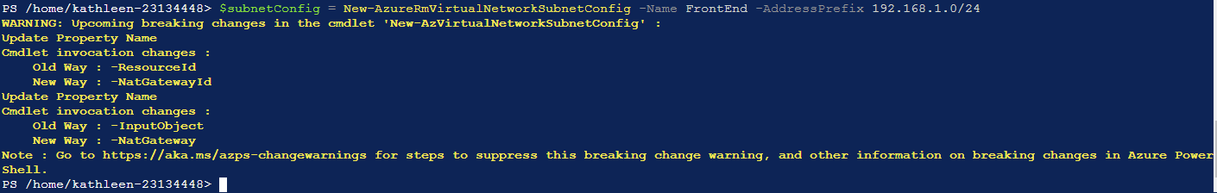$subnetConfig = New-AzureRmVirtualNetworkSubnetConfig –Name FrontEnd –AddressPrefix 192.168.1.0/24

$vnet = New-AzureRmVirtualNetwork –ResourceGroupName $resourceGroup –Location $location –Name ChallengeVnet –AddressPrefix 192.168.0.0/16 –Subnet $subnetConfig

$pip = New-AzureRmPublicIpAddress –ResourceGroupName $resourceGroup –Location $location –Name “challengepubdns$(Get-Random)” –AllocationMethod Static-IdleTimeoutInMinute 5

1. Create an Inbound network security group rule for port 3389:

$nsgRuleRDP = New-AzureRmNetworkSecurityRuleConfig -Name ChallengeRDP -Protocol Tcp -Direction Inbound -Priority 500 -SourceAddressPrefix * -SourcePortRange * -DestinationAddressPrefix * -DestinationPortRange 3389 -Access Allow

# Creating a network security group named ChallengeNSG:

$nsg = New-AzureRmNetworkSecurityGroup -ResourceGroupName $resourceGroup -Location $location -Name ChallengeNSG -SecurityRules $nsgRuleRDP

# Creating a virtual network card associated with public IP address & network security group:

$nic = New-AzureRmNetworkInterface -Name ChallengeNIC -ResourceGroupName $resourceGroup -Location $location -SubnetId $vnet.Subnets[0].Id -PublicIpAddressId $pip.Id -NetworkSecurityGroupId $nsg.Id

# Creating a virtual machine configuration:

$vmConfig = New-AzureRmVMConfig -VMName $vmName -VMSize Standard_D1_v2 | Set-AzureRmVMOperatingSystem -Windows -ComputerName $vmName -Credential $cred | Set-AzureRmVMSourceImage -PublisherName MicrosoftWindowsServer -Offer WindowsServer -Skus 2016-Datacenter -Version latest | Add-AzureRmVMNetworkInterface -Id $nic.Id

# Creating a VM:

New-AzureRmVM -ResourceGroupName $resourceGroup -Location $location -VM $vmConfig